You might only want to print 2 of these journeys (North Tyneside and Portsmouth) because they’re so long, groups might not have time to look at all 3 examples, unless you allot more time.

Customer journey: **Apply for a council house – NORTH SOMERSET DISTRICT COUNCIL**

How I got to this page: From **Google**, using search term ‘Get a council house north somerset’

Page on local authority website: Page 1–2 of 7

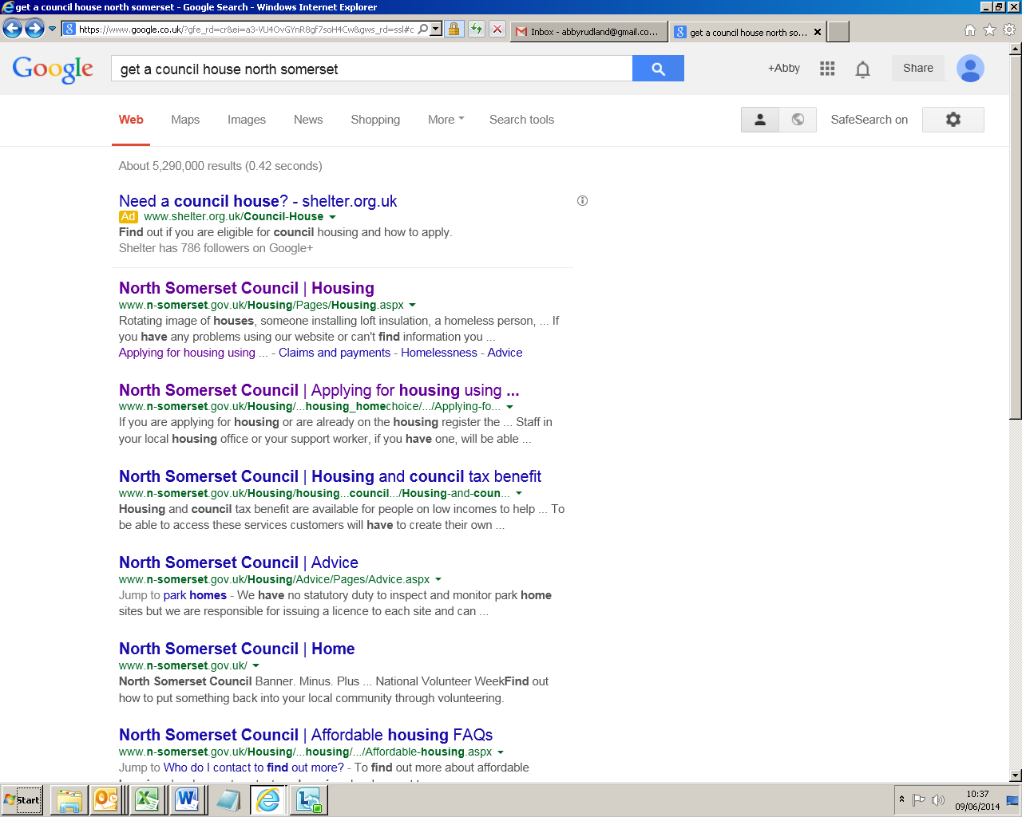

**I clicked here**

**Page 2 of 7**

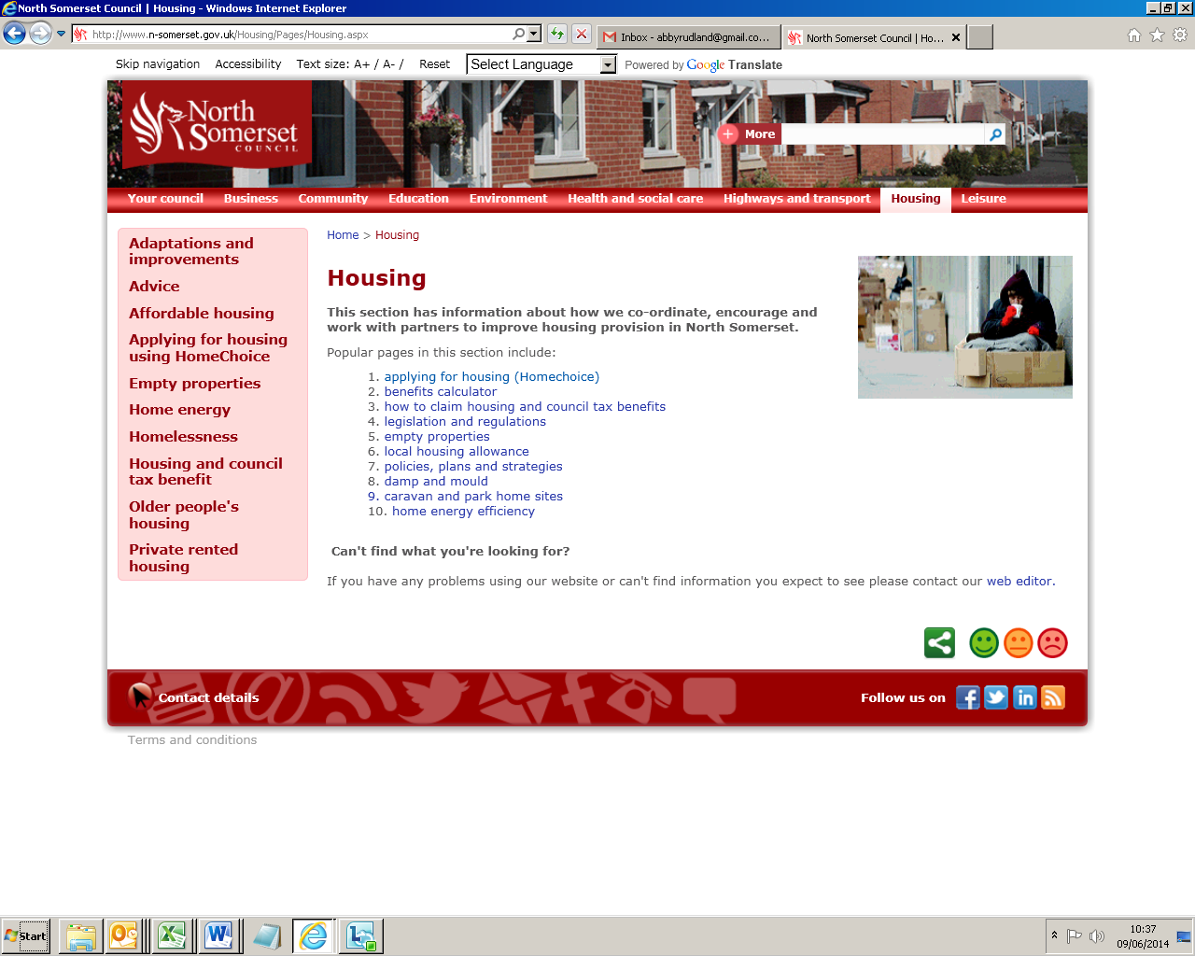

**I clicked here**

Customer journey: **Apply for a council house – NORTH SOMERSET DISTRICT COUNCIL**

How I got to this page: From **Google**, using search term ‘Get a council house north somerset’

Page on local authority website: Page 3 of 7

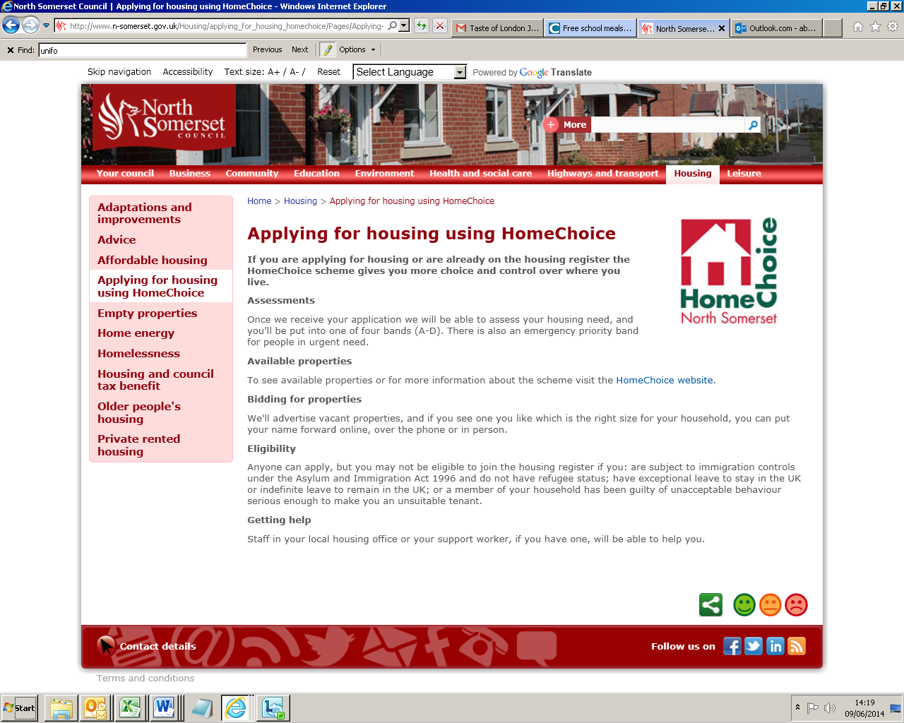

**I clicked here**

**Page 4 of 7**

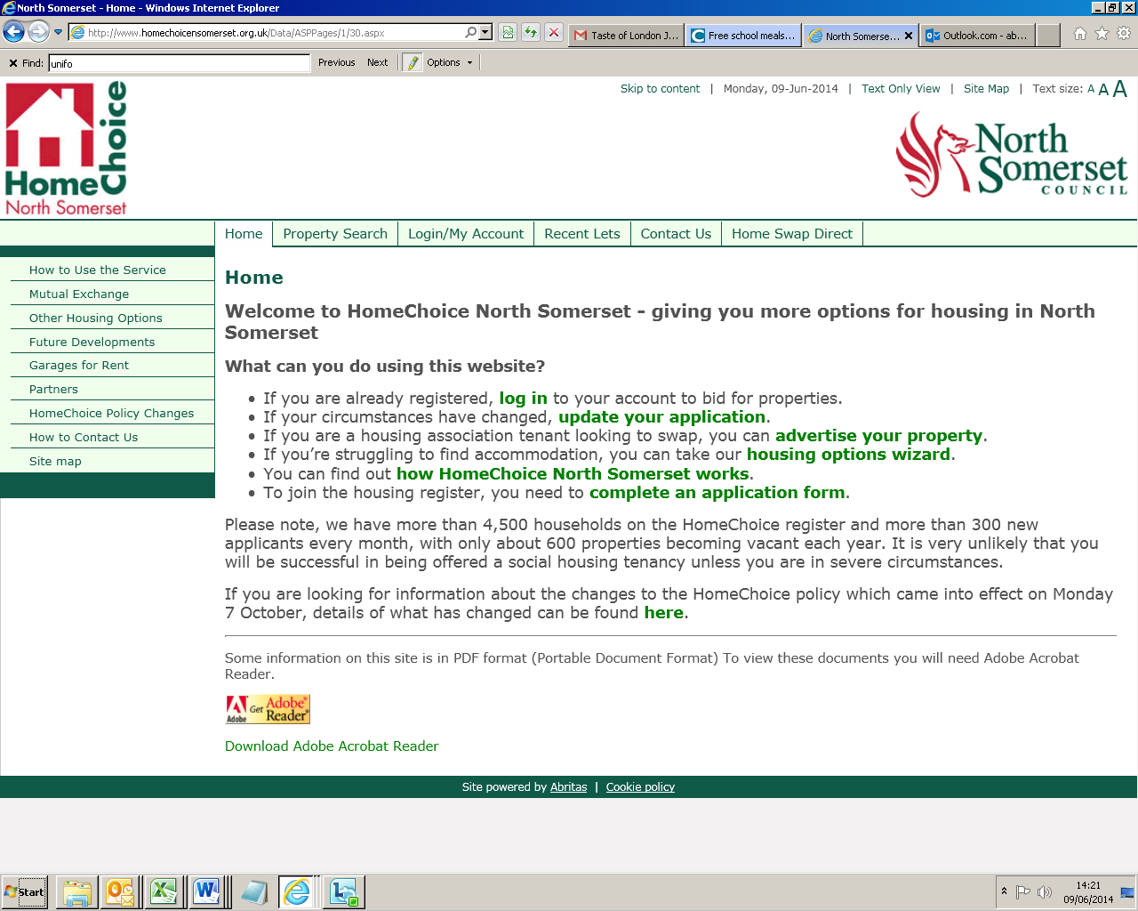

**I clicked here**

Customer journey: **Apply for a council house – NORTH SOMERSET DISTRICT COUNCIL**

How I got to this page: From **Google**, using search term ‘Get a council house north somerset’

Page on local authority website: Page 5 of 7

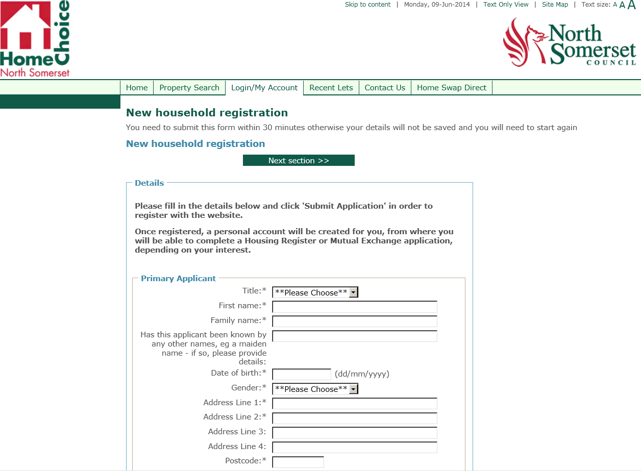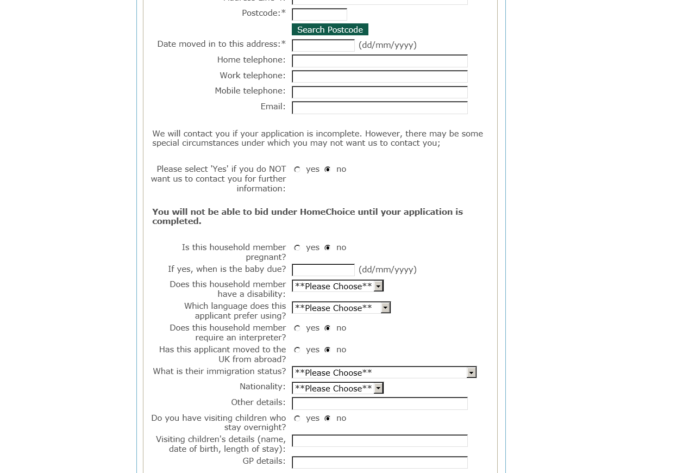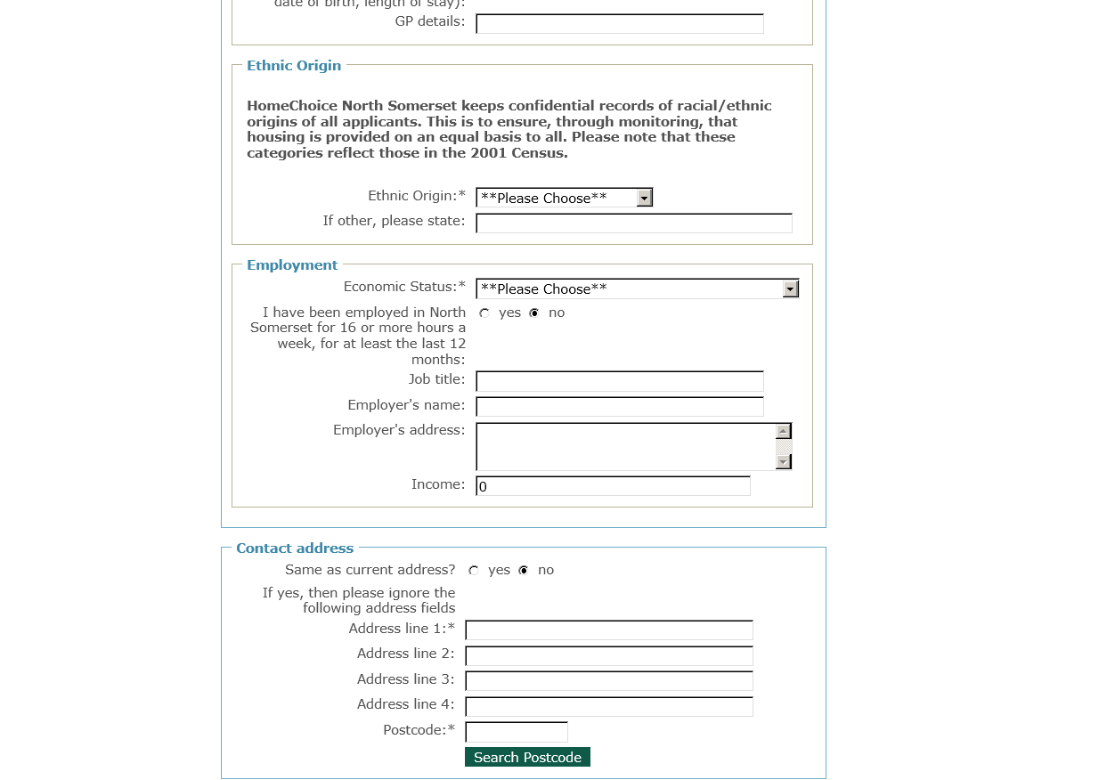

**I clicked here**

Customer journey: **Apply for a council house – NORTH SOMERSET DISTRICT COUNCIL**

How I got to this page: From **Google**, using search term ‘Get a council house north somerset’

Page on local authority website: Page 6 of 7

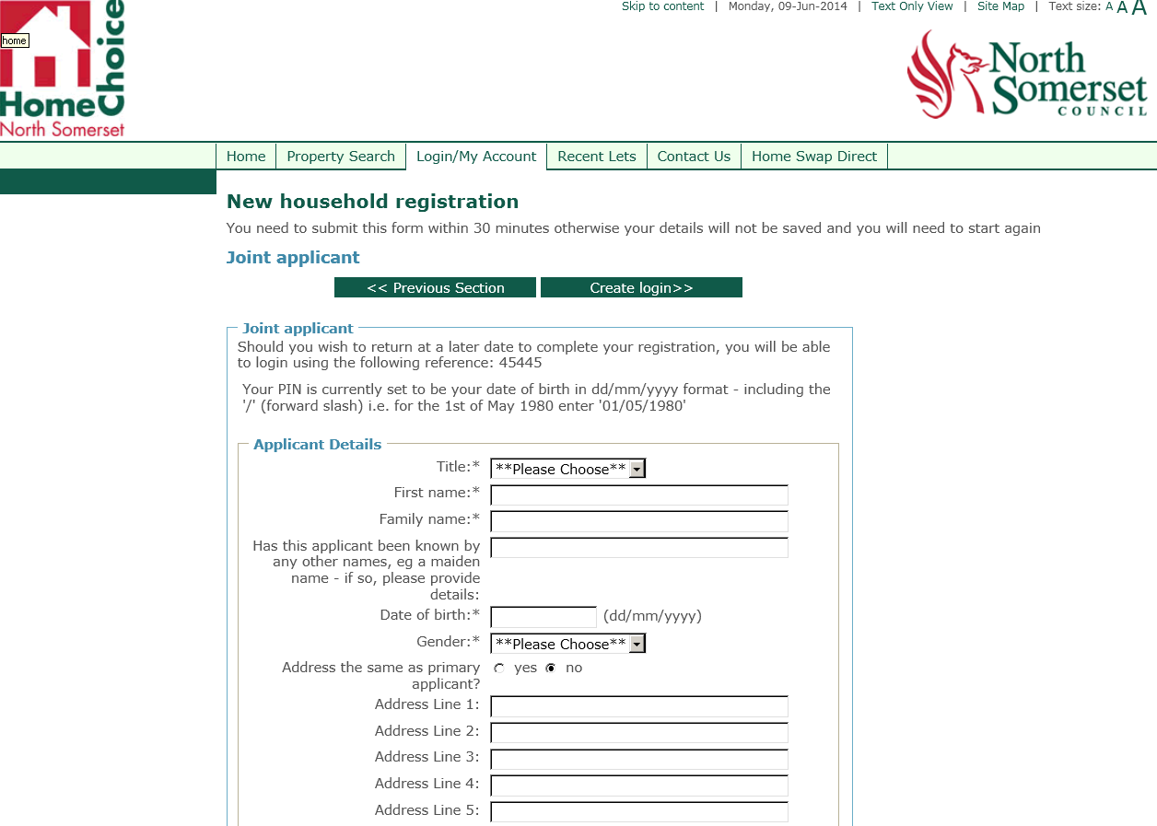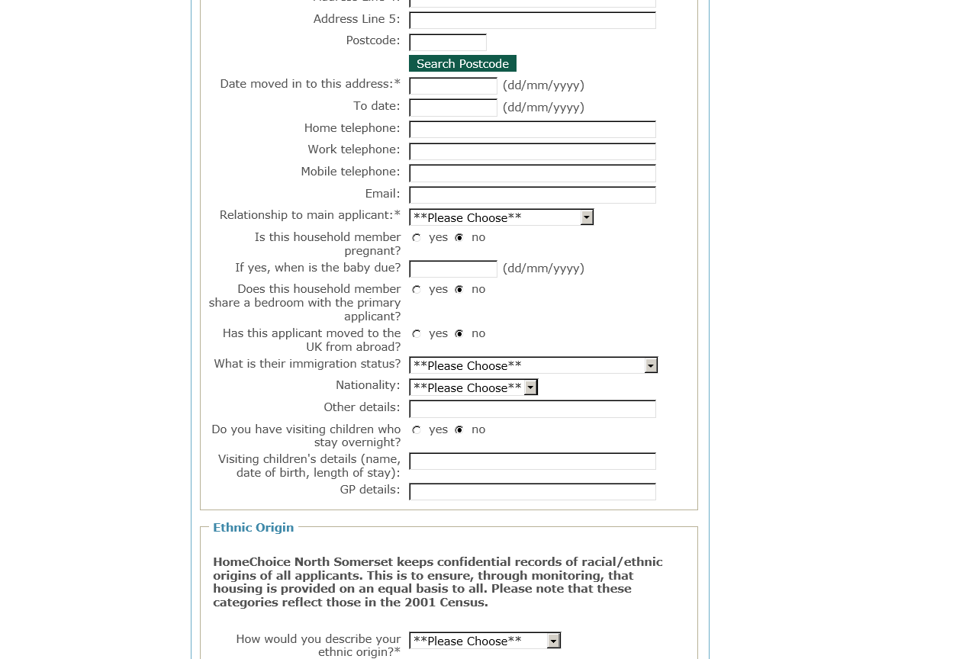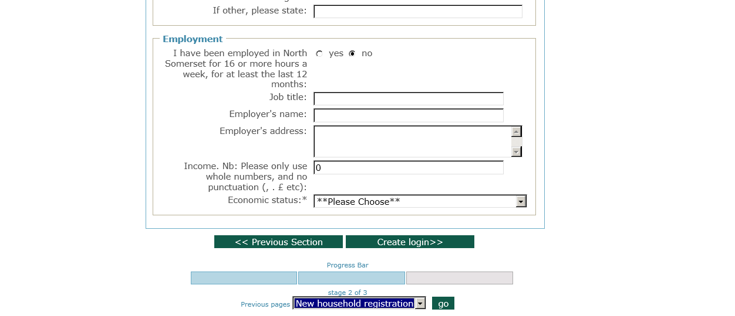

**I clicked here**

Customer journey: **Apply for a council house – NORTH SOMERSET DISTRICT COUNCIL**

How I got to this page: From **Google**, using search term ‘Get a council house north somerset’

Page on local authority website: Page 7 of 7

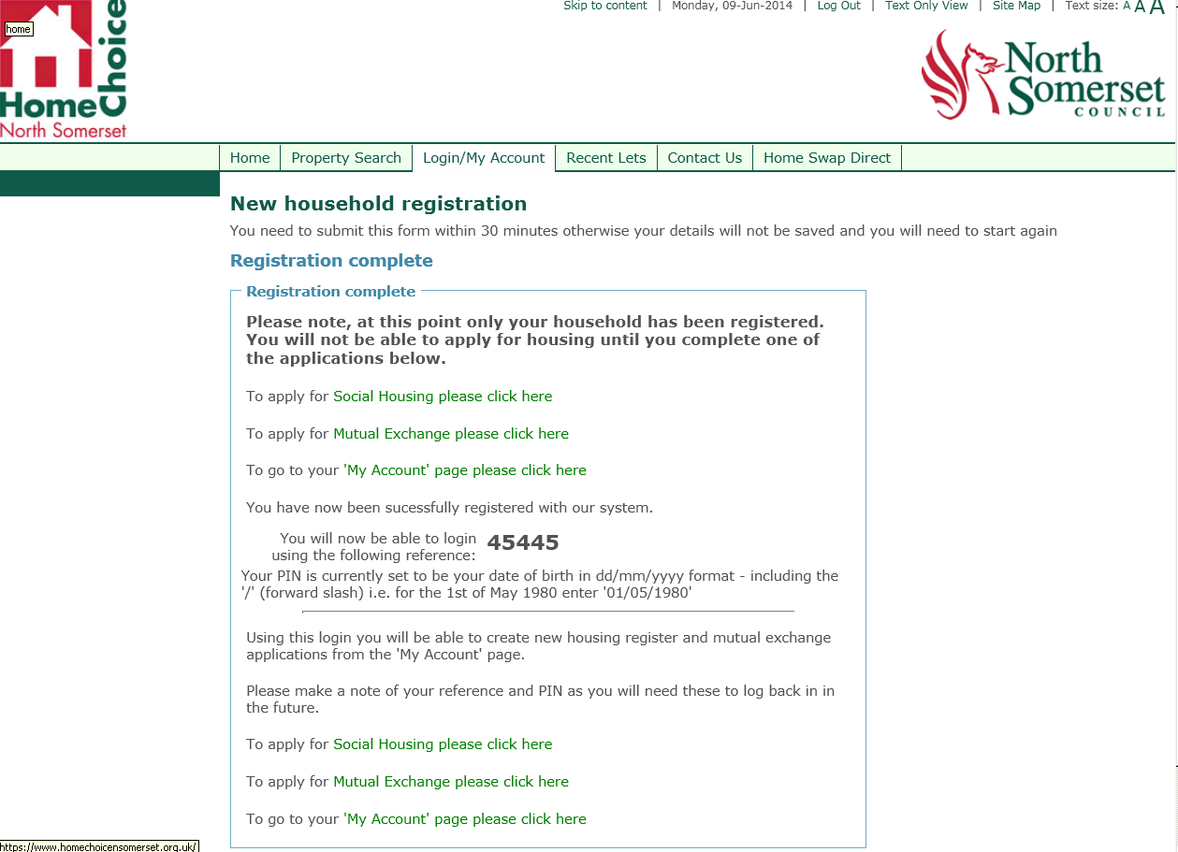

**At this point, as a nervous internet user, I might assume I’ve finished my application, because it says ‘Registration complete’.**

**I might not see that I have to still apply for social housing.**

Customer journey: **Apply for a council house – PORTSMOUTH COUNCIL**

How I got to this page: From **Google**, using search term ‘Get a council house portsmouth’

Page on local authority website: Page 1 of 2

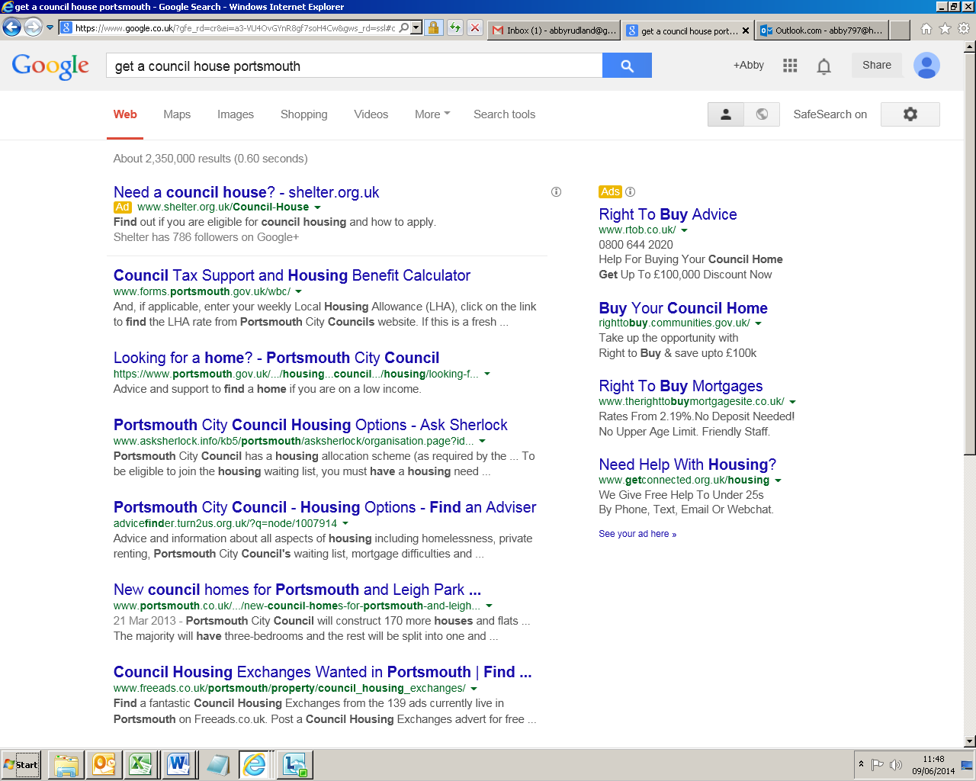

**I clicked here**

Customer journey: **Apply for a council house – PORTSMOUTH COUNCIL**

How I got to this page: From **Google**, using search term ‘Get a council house portsmouth’

Page on local authority website: Page 2 of 2

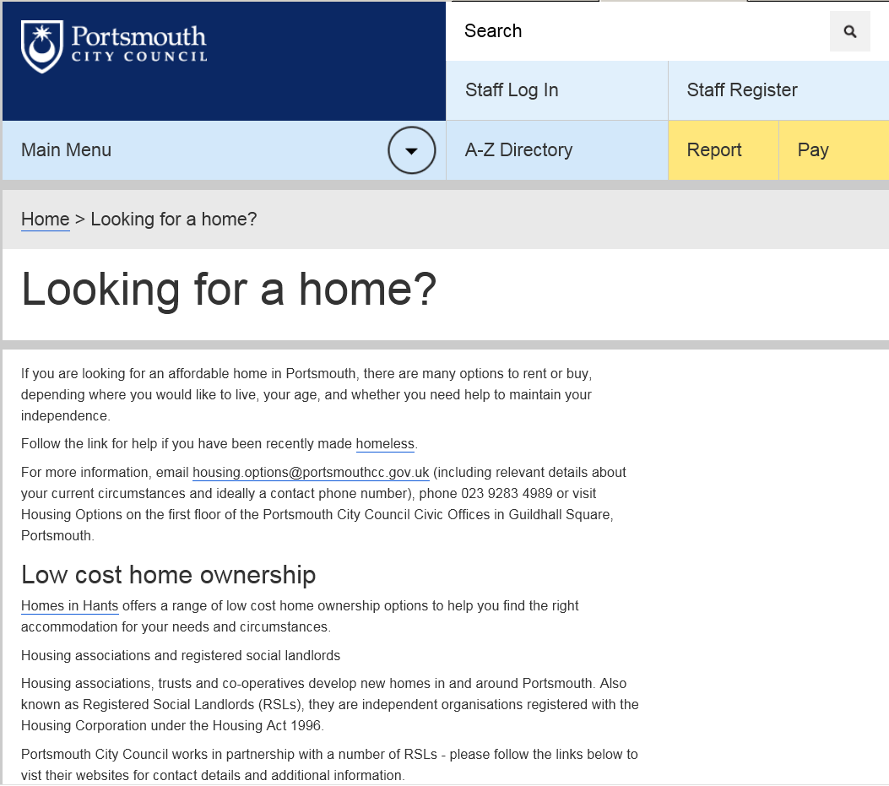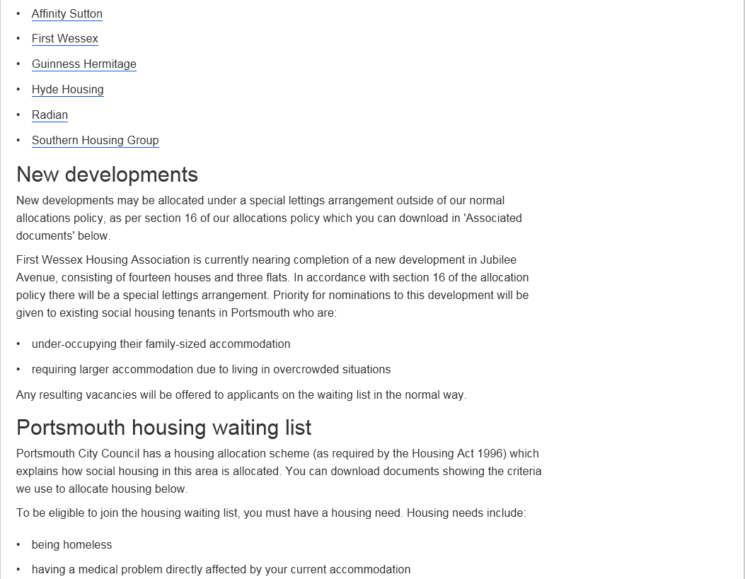

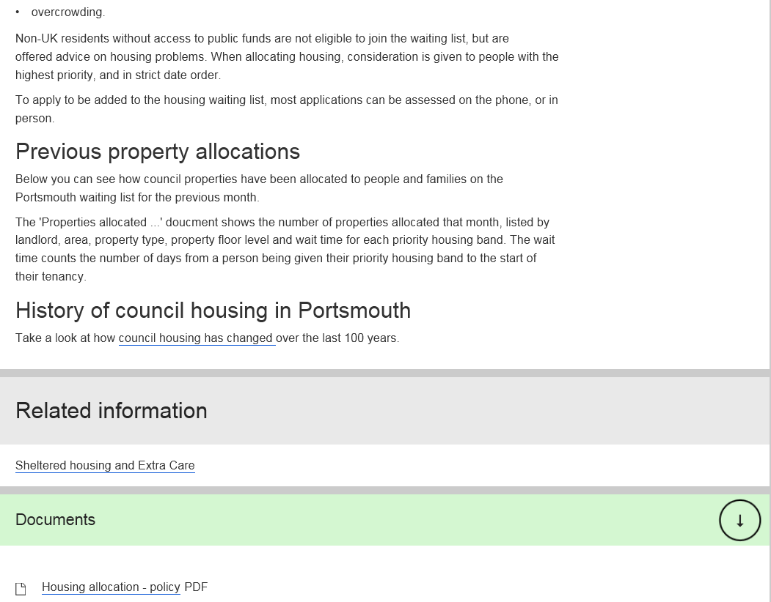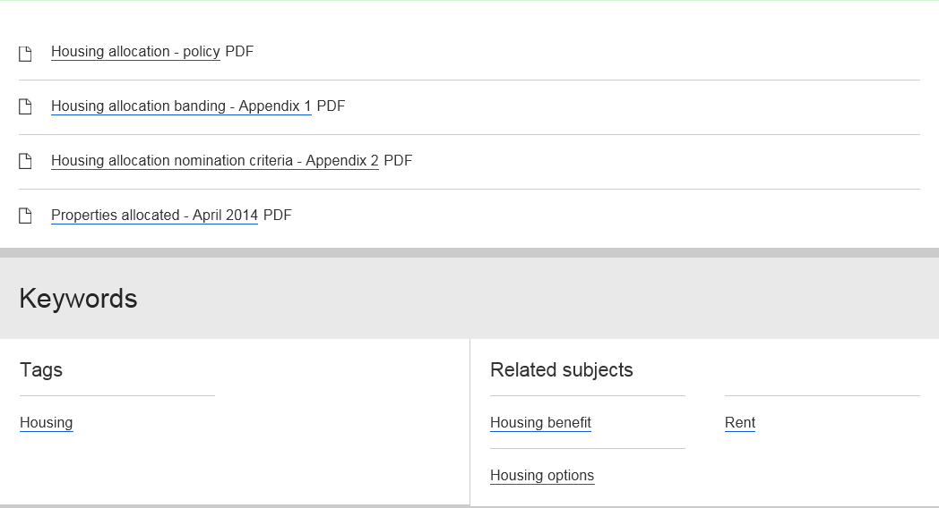

**It says I need to phone the council or see them in person. There are contact details at the top of the page.**

Customer journey: **Apply for a council house – NORTH TYNESIDE COUNCIL**

How I got to this page: From **Google**, using search term ‘Get a council house north tyneside’

Page on local authority website: Page 1 of 8

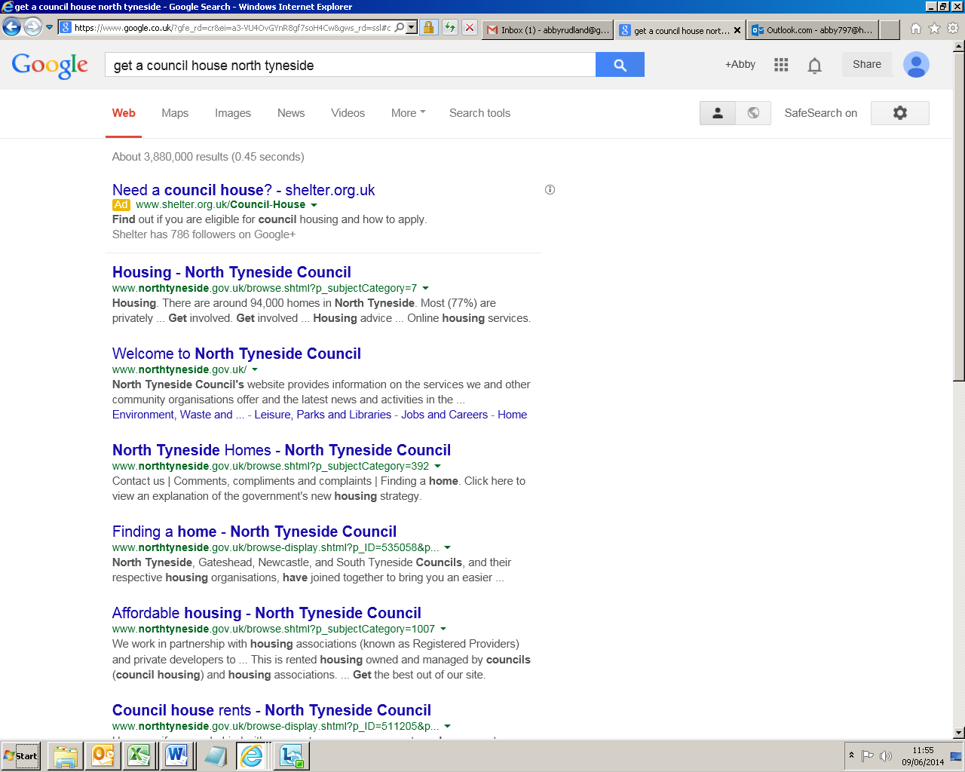

**I clicked here**

Customer journey: **Apply for a council house – NORTH TYNESIDE COUNCIL**

How I got to this page: From **Google**, using search term ‘Get a council house north tyneside’

Page on local authority website: Page 2 of 8

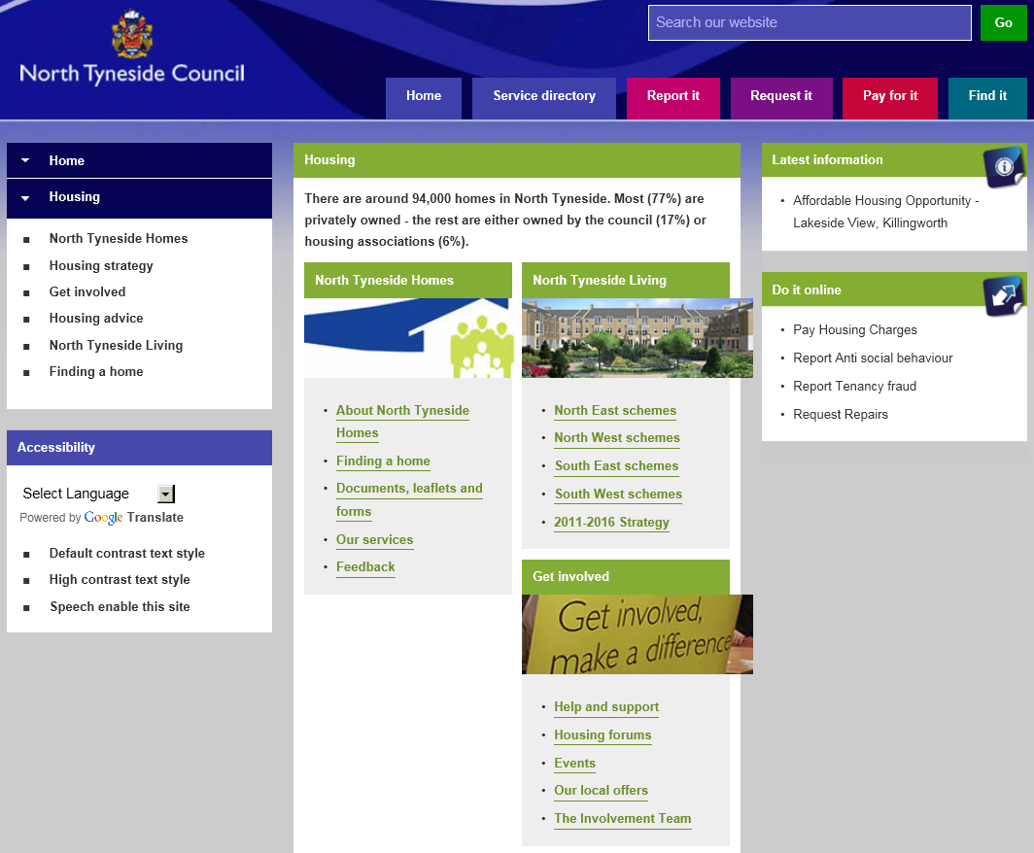

**I clicked here**

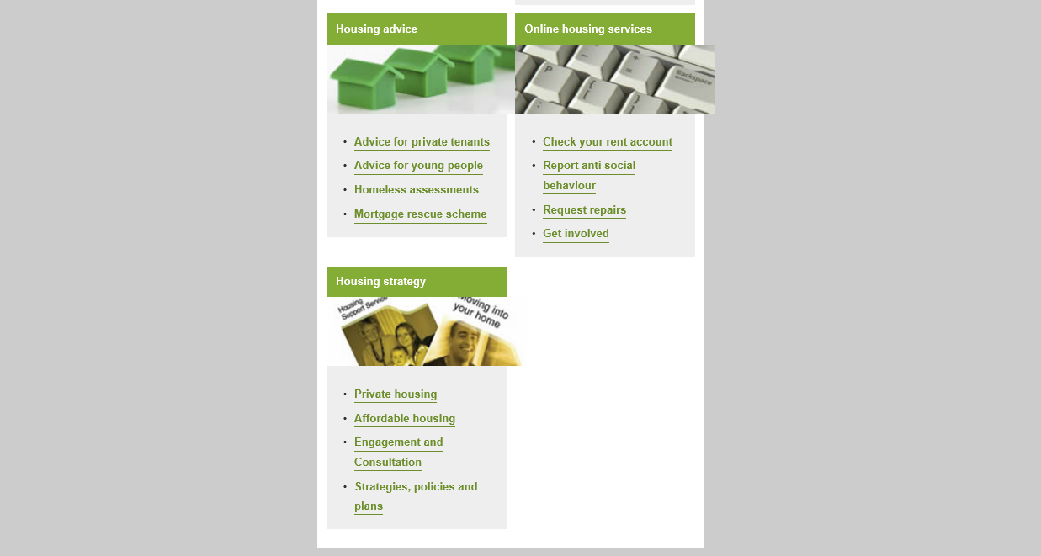

Customer journey: **Apply for a council house – NORTH TYNESIDE COUNCIL**

How I got to this page: From **Google**, using search term ‘Get a council house north tyneside’

Page on local authority website: Page 3 of 8

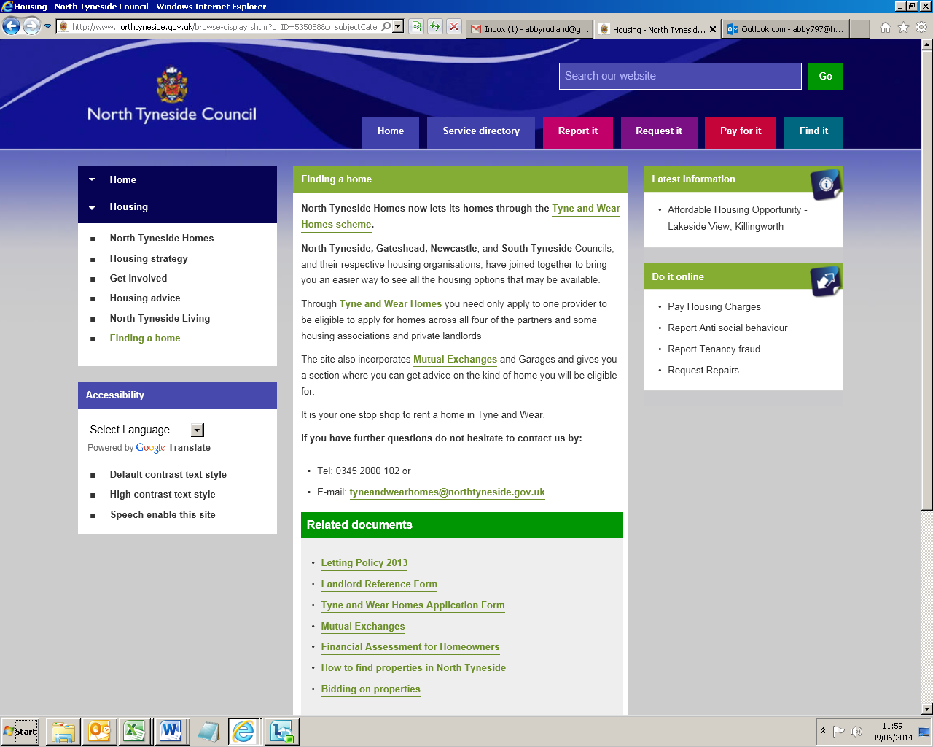

**I clicked here**

**Page 4 of 8**

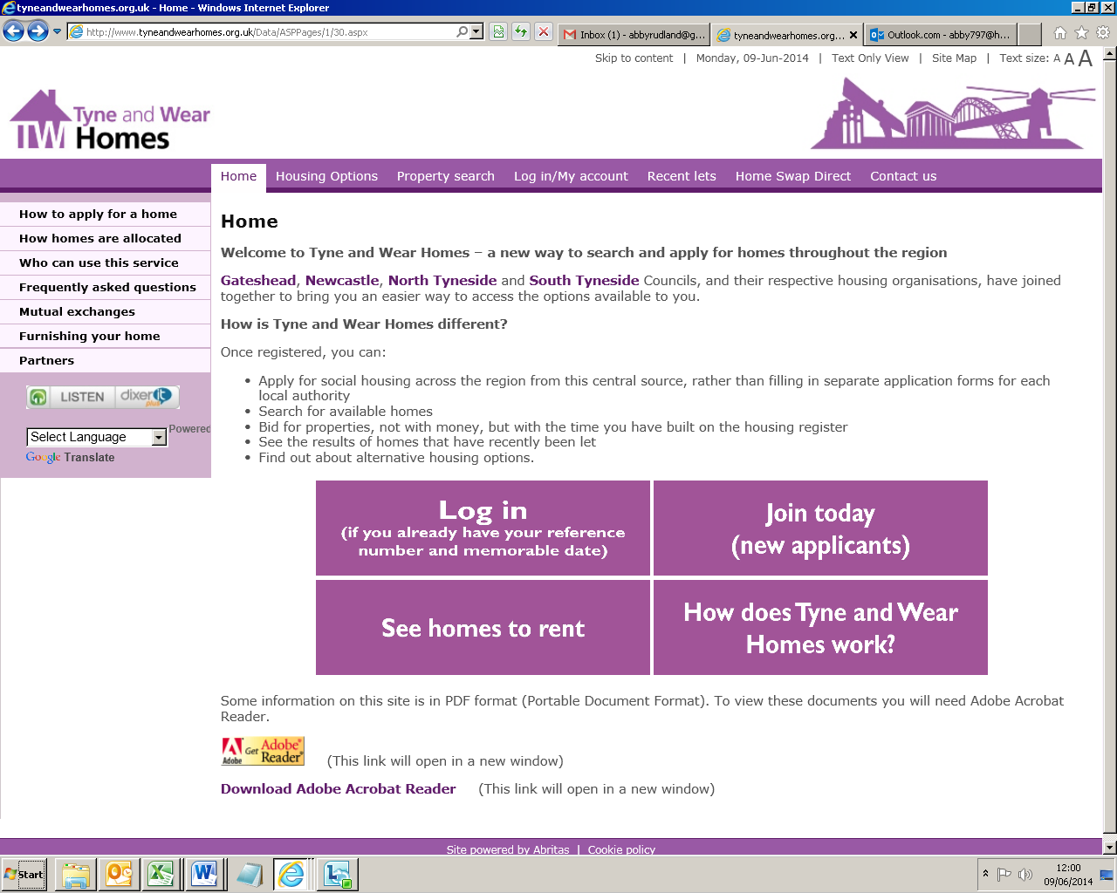

**I clicked here**

Customer journey: **Apply for a council house – NORTH TYNESIDE COUNCIL**

How I got to this page: From **Google**, using search term ‘Get a council house north tyneside’

Page on local authority website: Page 5 of 8

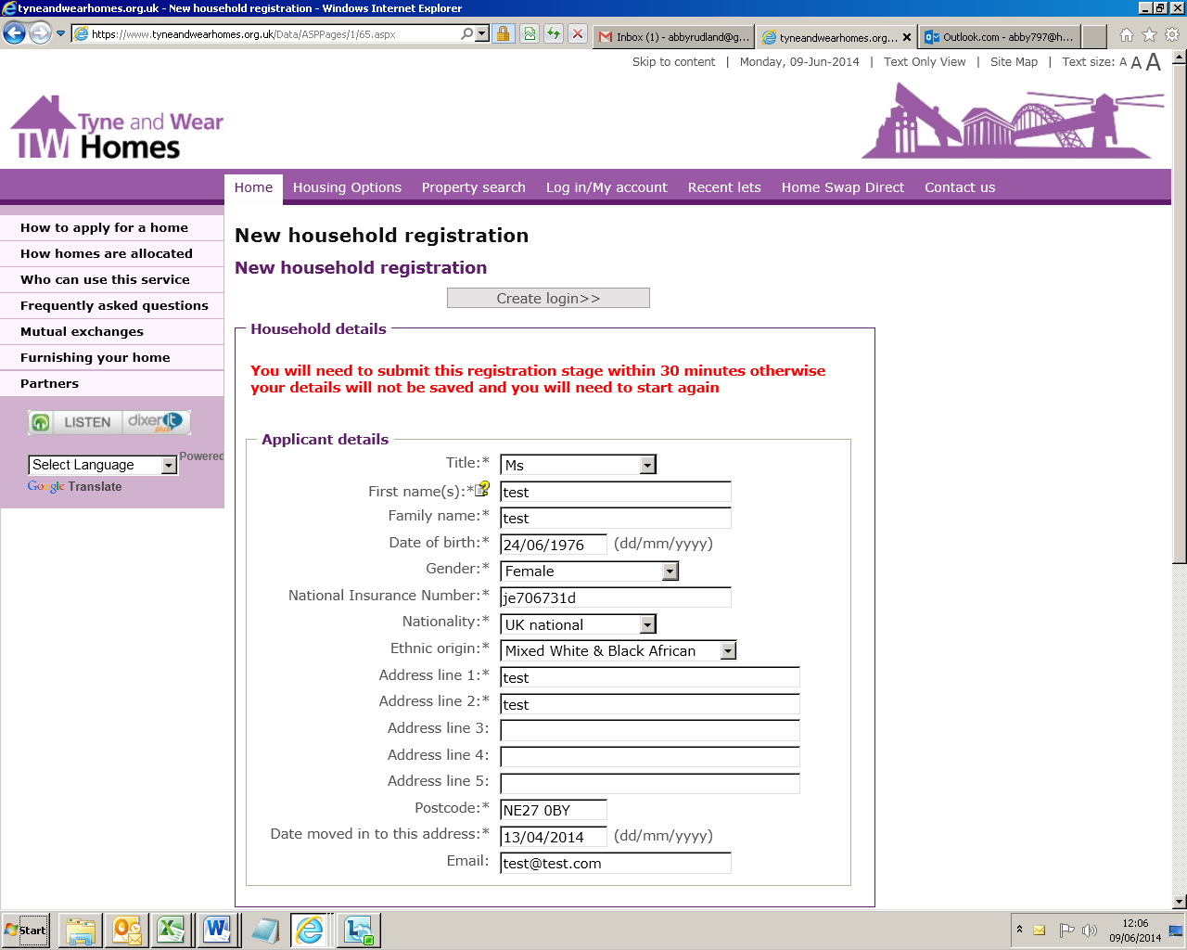

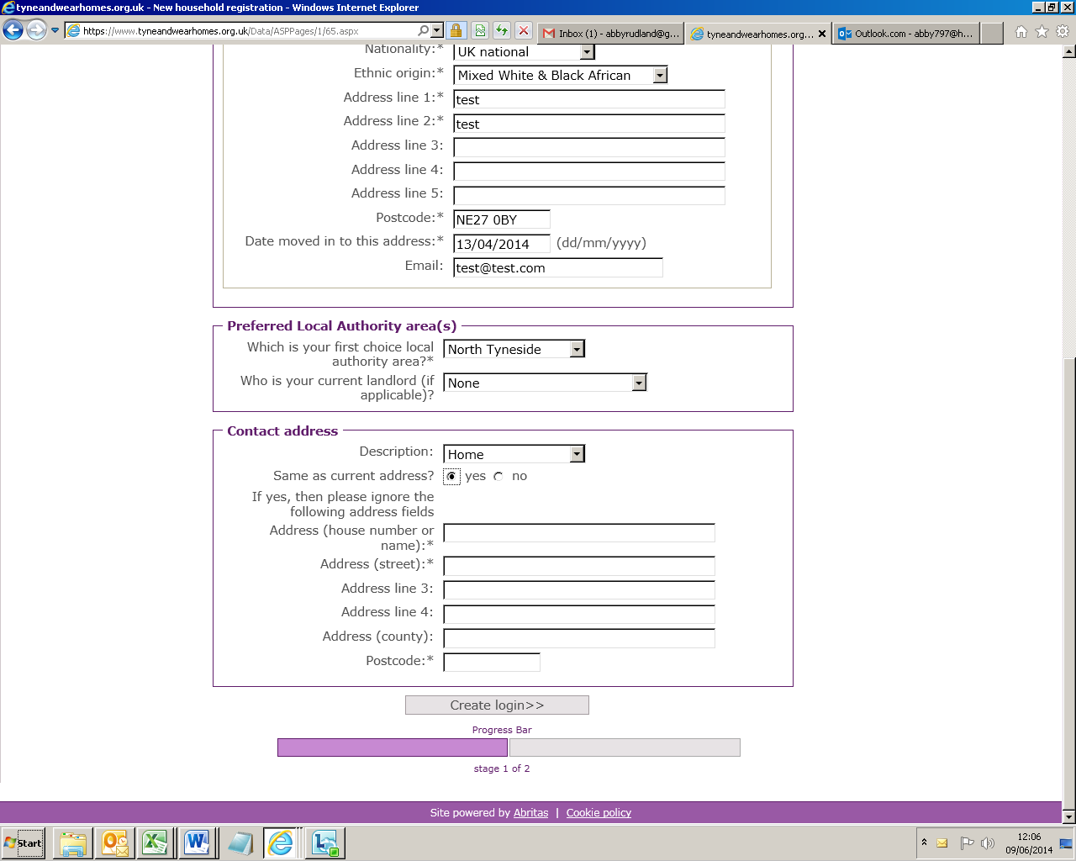

**I clicked here**

Customer journey: **Apply for a council house – NORTH TYNESIDE COUNCIL**

How I got to this page: From **Google**, using search term ‘Get a council house north tyneside’

Page on local authority website: Page 6 of 8

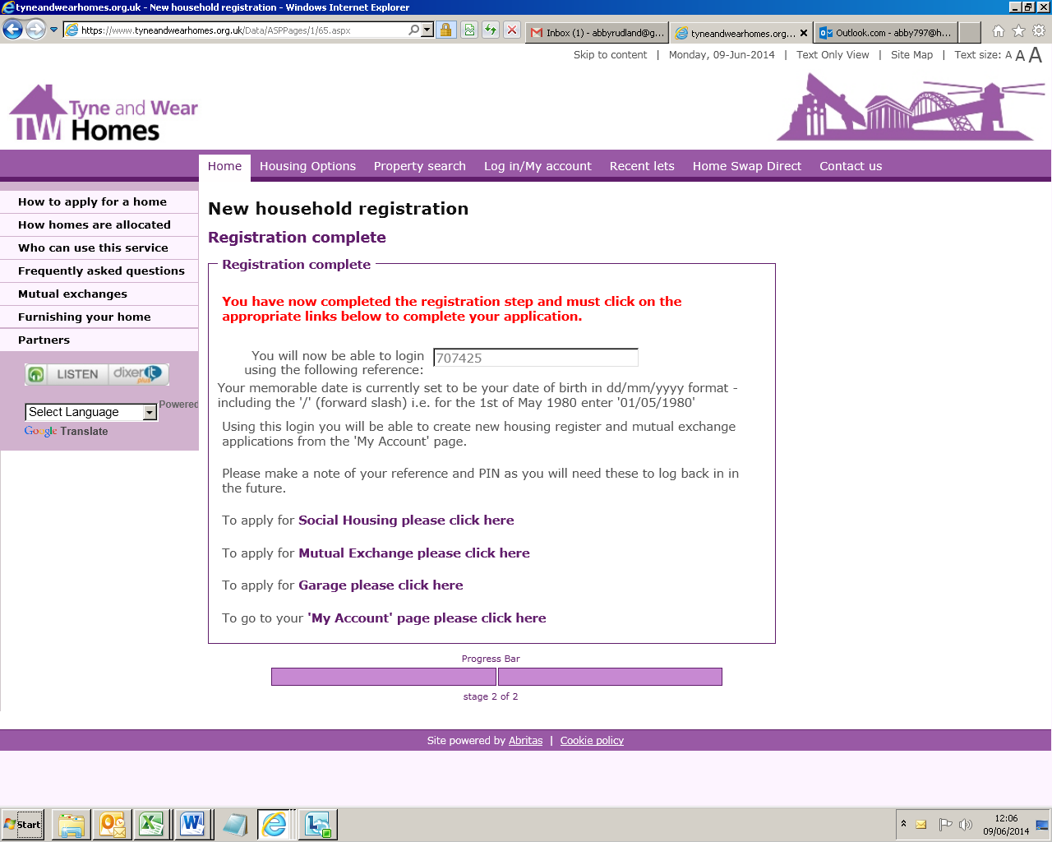

**I clicked here**

**Page 7 of 8**

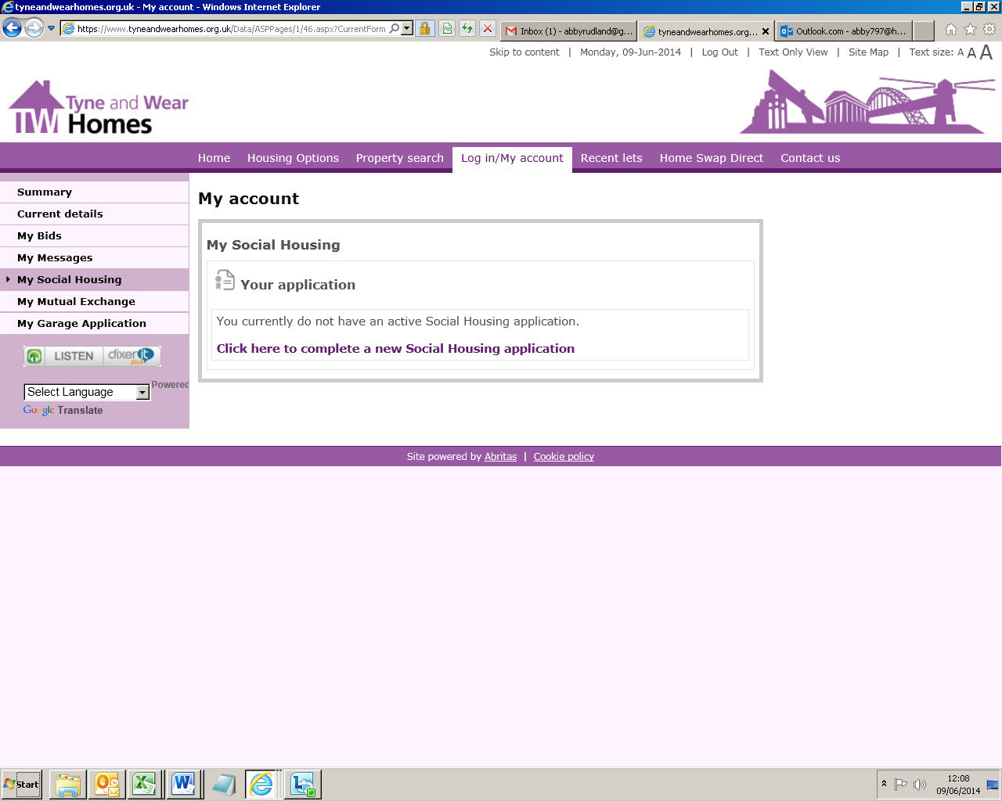

**I clicked here**

Customer journey: **Apply for a council house – NORTH TYNESIDE COUNCIL**

How I got to this page: From **Google**, using search term ‘Get a council house north tyneside’

Page on local authority website: Page 8 of 8

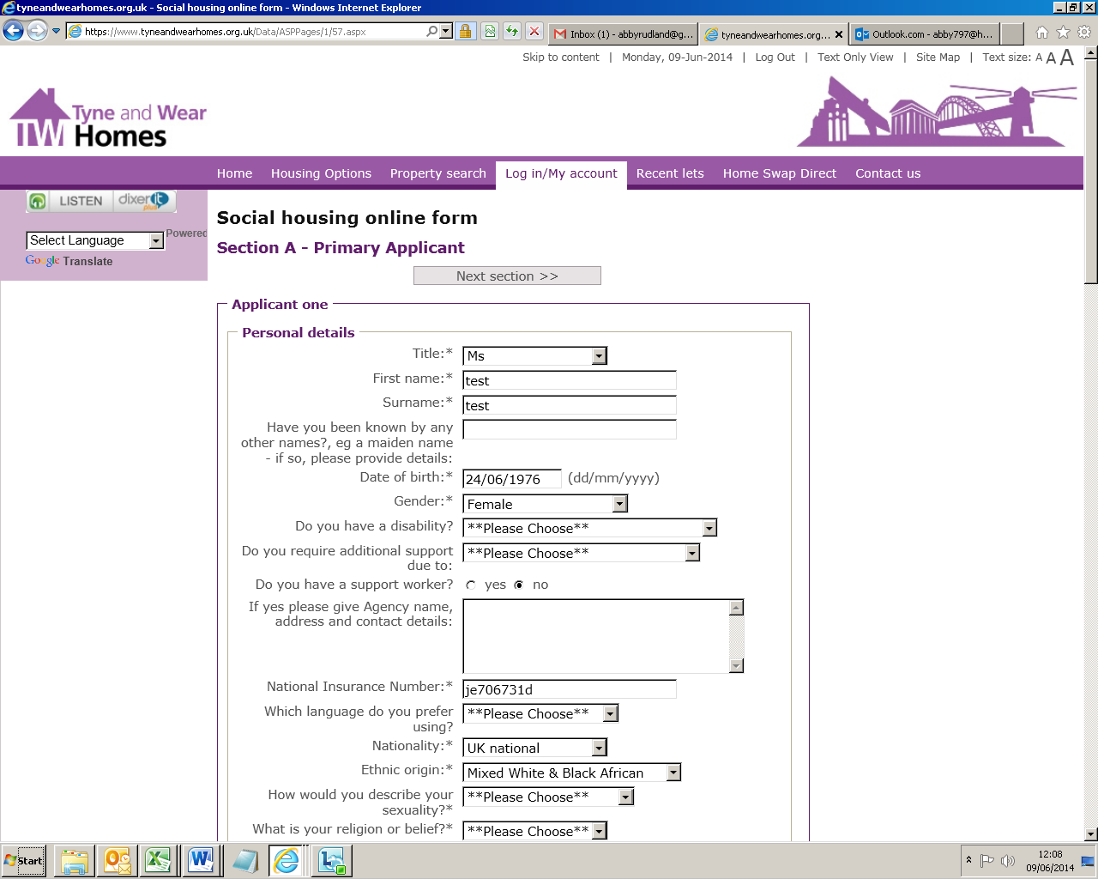

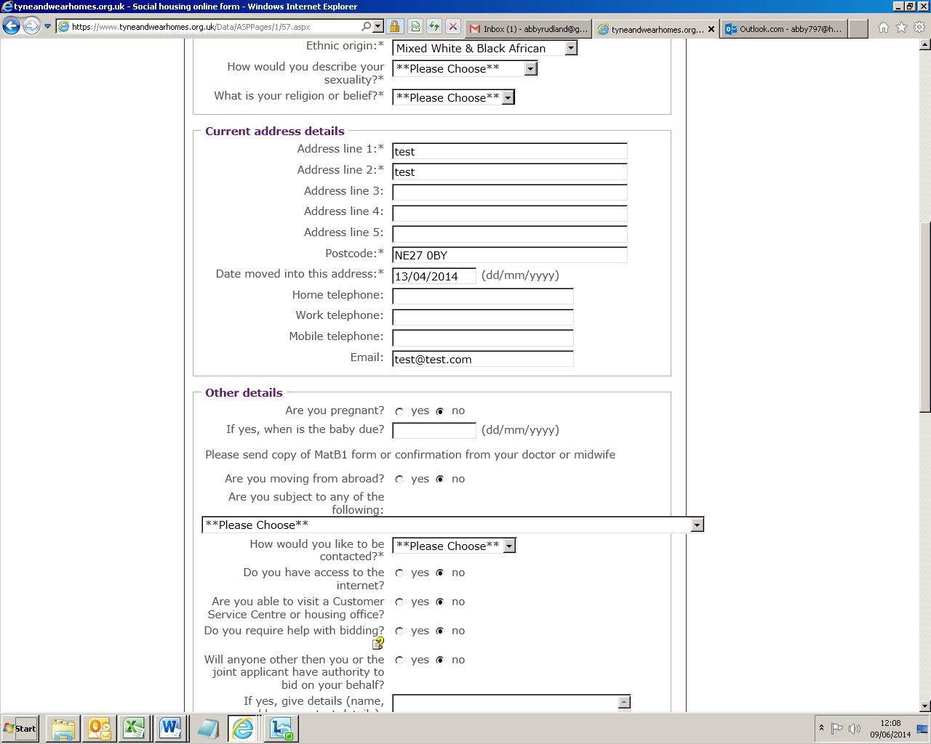

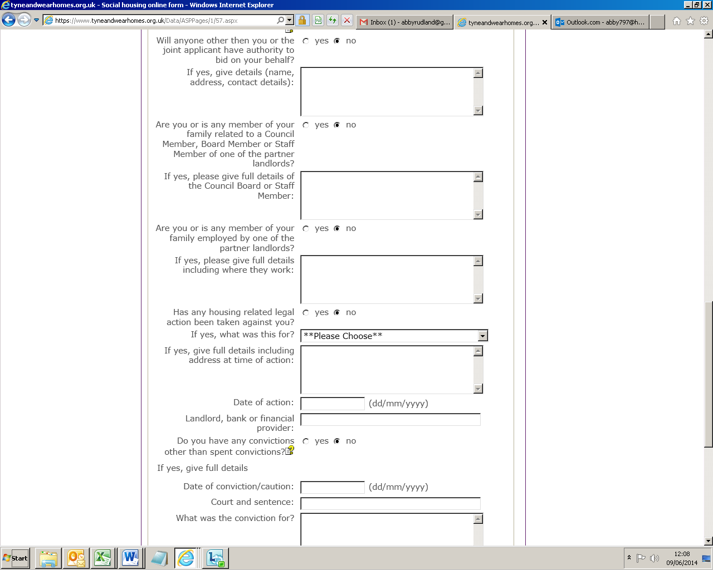

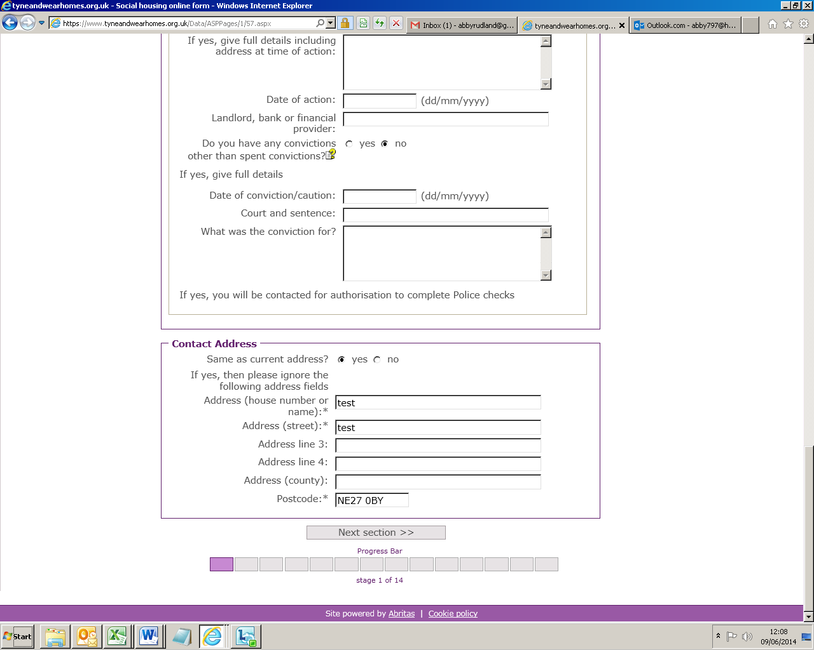

**This form carries on for 13 pages**